Фамилия Имя ________________________ дата___________ класс ___________

**ЗАЧЁТ**

**«Химическая посуда и оборудование»**

1. *Заполни таблицу.*

|  |  |  |  |
| --- | --- | --- | --- |
|  | Название прибора | Применение |  |
| 1 |  |  |  |
| 2 |  |  |  |
| 3 |  |  |  |
| 4 |  |  |  |
| 5 |  |  |  |
| 6 |  |  |  |
| 7 |  |  |  |
| 8 |  |  |  |
| 9 |  |  |  |
| 10 |  |  |  |

1. *Укажи название прибора, его строение, правила работы и применение.*

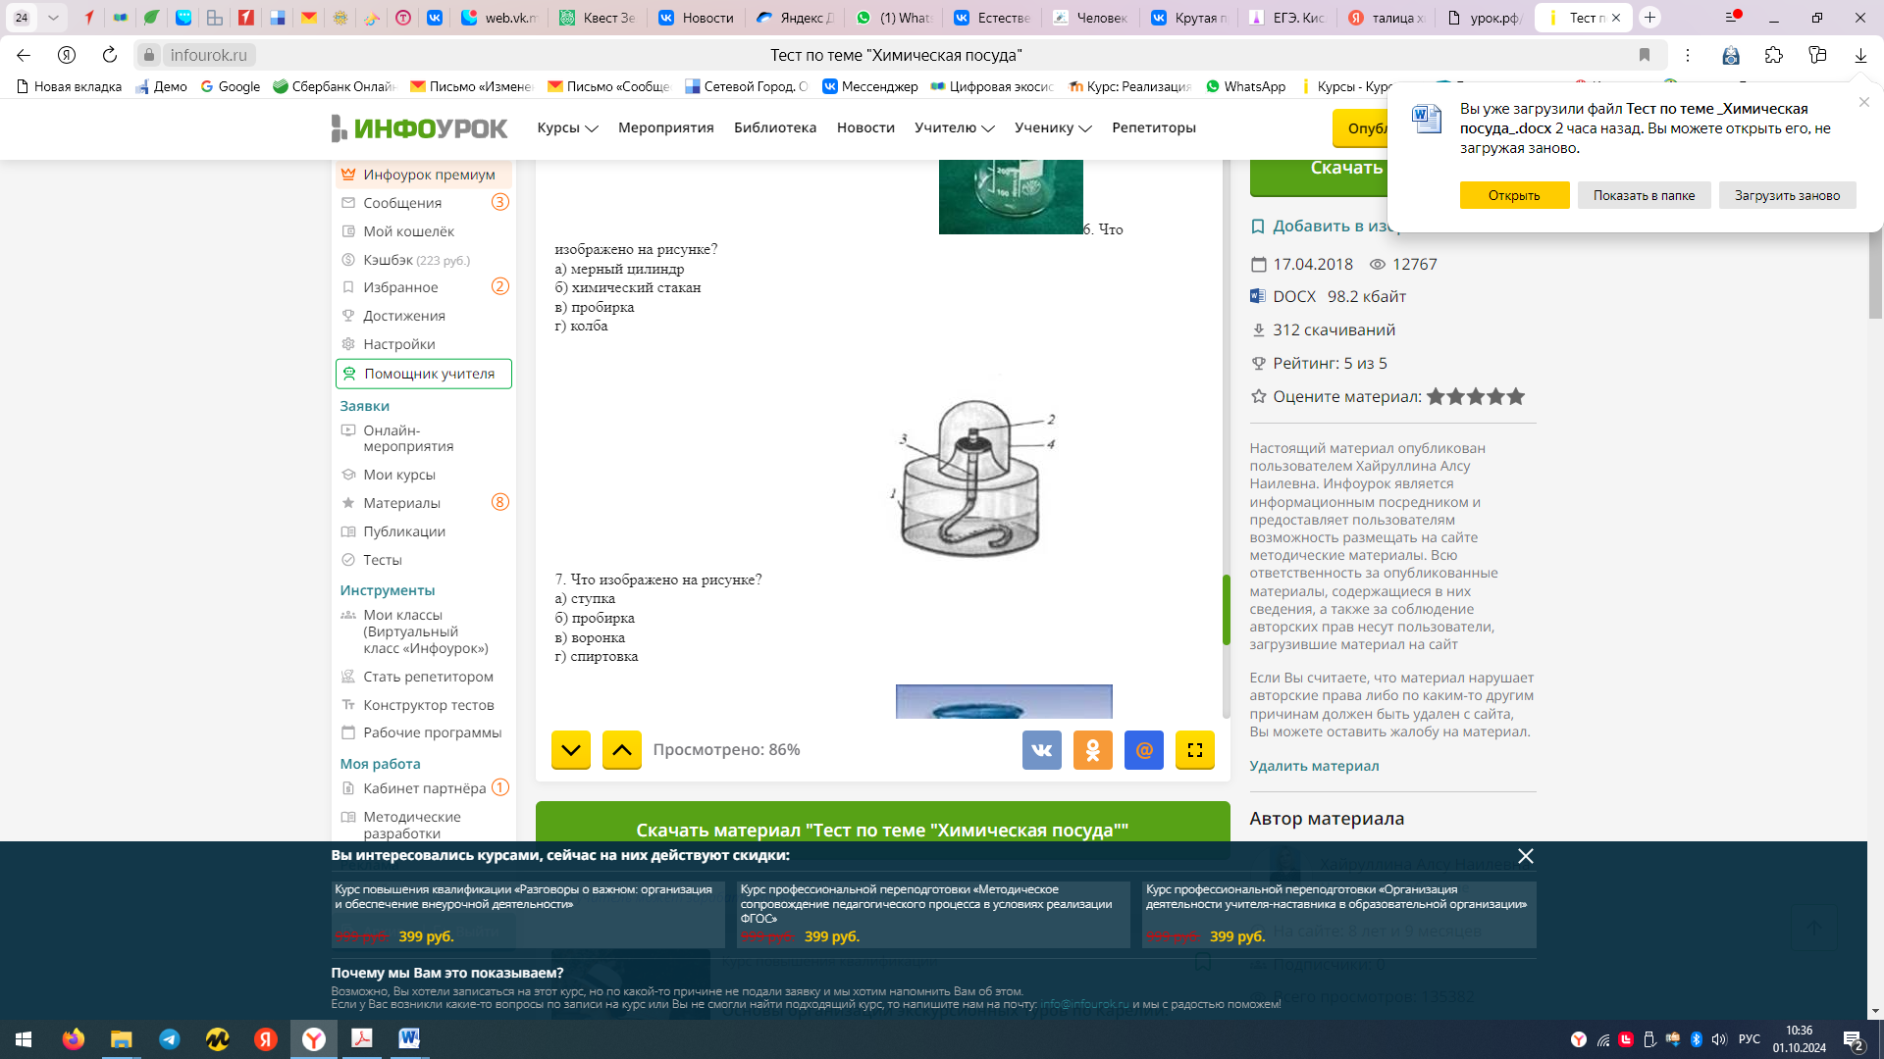 Название прибора________________

Строение прибора: Правила работы:

1 - ____________ 1 - ______________________________

2 - ____________ 2 - ______________________________

3 - ____________ 3 - ______________________________

4 - _____________ 4 - ______________________________

1. *Запиши 5 правил поведения в кабинете химии:*

____________________________________________________________________________________

____________________________________________________________________________________________

____________________________________________________________________________________________

____________________________________________________________________________________________

____________________________________________________________________________________________